3) The circuit detects the presence of a 17 kHz infrared modulation signal. The first two op-amps form a two-stage Sallen-Key band-pass filter that is tuned to approximately 17 kHz. This filter allows signals near 17 kHz to pass while attenuating other frequencies and noise. When the 17 kHz switch is turned on, the IR receiver produces a signal at this frequency, and the band-pass filter outputs a larger AC signal. This signal is then sent to the peak detector, which is built using an op-amp, diode, and capacitor. The peak detector converts the AC signal into a DC voltage proportional to the signal amplitude. This DC voltage is applied to a comparator stage that compares it with a reference voltage. If the detected signal voltage is higher than the reference level, the comparator output goes high and drives current through the LED, turning it on. When the 17 kHz switch is turned off, there is no 17 kHz signal at the input, the band-pass filter output remains very small, the peak detector does not produce a significant DC voltage, and the comparator output stays low, so the LED remains off.

4)
a)
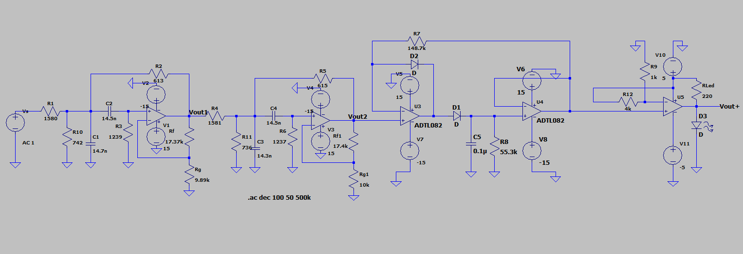

b)
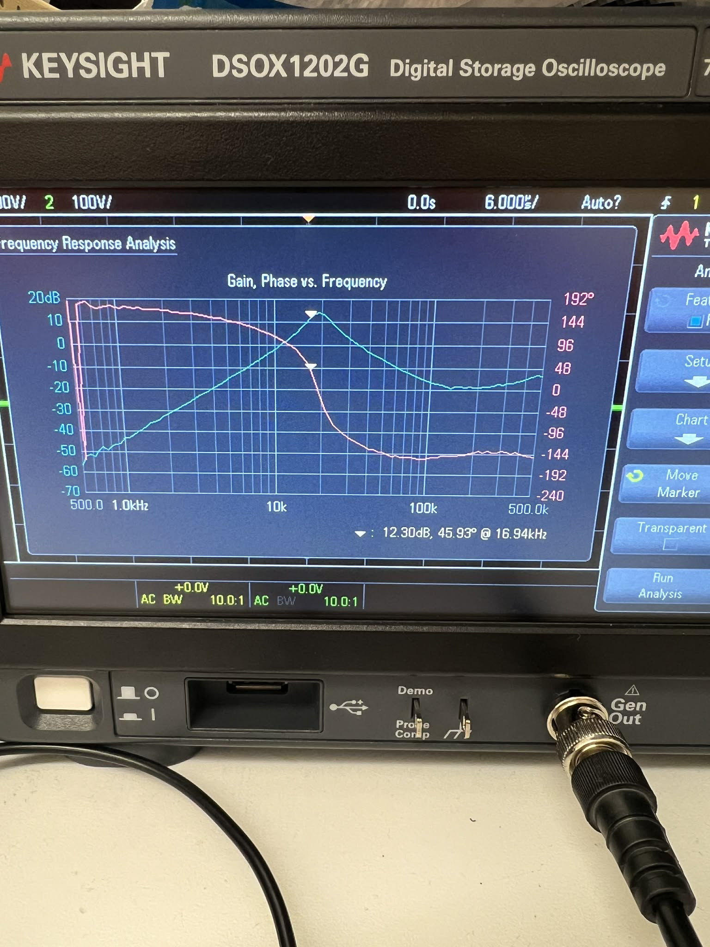
i) Number of stages implemented
The filter uses 2 cascaded Sallen-Key active band-pass stages.
ii) Q for each stage
Stage 1 Q ≈ 3.8
Stage 2 Q ≈ 3.8
Both stages are designed with the same quality factor to achieve sufficient attenuation at 10 kHz and 25 kHz while passing the center frequency at 17 kHz.
iii) Gains for each stage and total passband gain
For a Sallen-Key stage:
Q = 1 / (3 − A)
Solve for A:
A = 3 − 1/Q
For Q = 3.8
A = 3 − 1/3.8
A ≈ 2.74
Stage gains
Stage 1 gain ≈ 2.74
Stage 2 gain ≈ 2.74
Total gain of the cascaded filter
Atotal = A1 × A2
Atotal = 2.74 × 2.74
Atotal ≈ 7.51
Total passband gain in dB
20 log10(7.51) ≈ 17.5 dB
Final summary
Number of stages: 2
Stage 1 Q: 3.8
Stage 2 Q: 3.8
Stage 1 gain: ≈ 2.74
Stage 2 gain: ≈ 2.74
Total passband gain: ≈ 7.51 (≈ 17.5 dB)

